Batch: A2 Roll No.: 16010322014
Experiment / assignment / tutorial No. 6
Grade: AA / AB / BB / BC / CC / CD /DD
Signature of the Staff In-charge with date

Title: Configuring Rapid PVST+, PortFast, and BPDU Guard

Objectives:
Part 1: Build the Network and Configure Basic Device Settings
Part 2: Configure VLANs, Native VLAN, and Trunks
Part 3: Configure the Root Bridge and Examine PVST+ Convergence
Part 4: Configure Rapid PVST+, PortFast, BPDU Guard, and Examine Convergence

OUTCOME:
CO 3. Understand and classify dynamic routing protocols

Tools required:
Packet Tracer software

Theory:
The Per-VLAN Spanning Tree (PVST) protocol is Cisco proprietary. Cisco switches default to PVST. Rapid PVST+ (IEEE 802.1w) is an enhanced version of PVST+ and allows for faster spanning-tree calculations and convergence in response to Layer 2 topology changes. Rapid PVST+ defines three port states: discarding, learning, and forwarding, and provides multiple enhancements to optimize network performance.
In this lab, you will configure the primary and secondary root bridge, examine PVST+ convergence, configure Rapid PVST+ and compare its convergence to PVST+. In addition, you will configure edge ports to transition immediately to a forwarding state using PortFast and prevent the edge ports from forwarding BDPUs using BDPU guard.

Task:
Topology
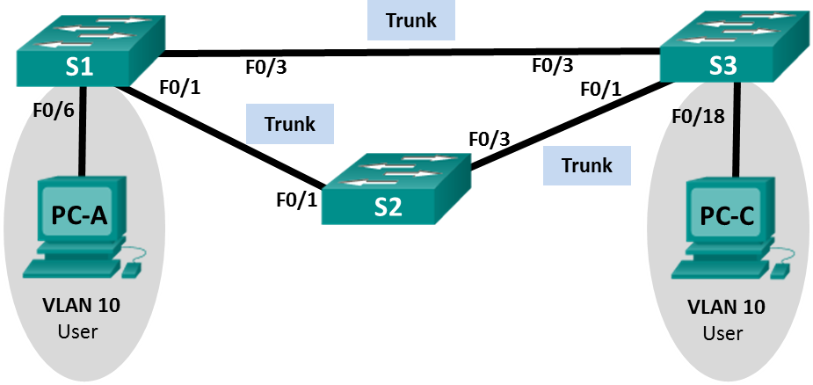

Addressing Table
Device | Interface | IP Address | Subnet Mask
S1 | VLAN 99 | 192.168.1.11 | 255.255.255.0
S2 | VLAN 99 | 192.168.1.12 | 255.255.255.0
S3 | VLAN 99 | 192.168.1.13 | 255.255.255.0
PC-A | NIC | 192.168.0.2 | 255.255.255.0
PC-C | NIC | 192.168.0.3 | 255.255.255.0
VLAN Assignments
VLAN | Name
10 | User
99 | Management
- Build the Network and Configure Basic Device Settings
In Part 1, you will set up the network topology and configure basic settings, such as the interface IP addresses, device access, and passwords.

  - Cable the network as shown in the topology.
  - Configure PC hosts.
  - Initialize and reload the switches as necessary.
  - Configure basic settings for each switch.
    - Disable DNS lookup.
    - Configure the device name as shown in the Topology.
    - Assign cisco as the console and vty passwords and enable login.
    - Assign class as the encrypted privileged EXEC mode password.
    - Configure logging synchronous to prevent console messages from interrupting command entry.
    - Shut down all switch ports.
    - Copy the running configuration to startup configuration.
- Configure VLANs, Native VLAN, and Trunks
In Part 2, you will create VLANs, assign switch ports to VLANs, configure trunk ports, and change the native VLAN for all switches.
Note: The required commands for Part 2 are provided in Appendix A. Test your knowledge by trying to configure the VLANs, native VLAN, and trunks without referring to the appendix.
  - Create VLANs.
Use the appropriate commands to create VLANs 10 and 99 on all of the switches. Name VLAN 10 as User and VLAN 99 as Management.
S1(config)# vlan 10
S1(config-vlan)# name User
S1(config-vlan)# vlan 99
S1(config-vlan)# name Management

S2(config)# vlan 10
S2(config-vlan)# name User
S2(config-vlan)# vlan 99
S2(config-vlan)# name Management

S3(config)# vlan 10
S3(config-vlan)# name User
S3(config-vlan)# vlan 99
S3(config-vlan)# name Management
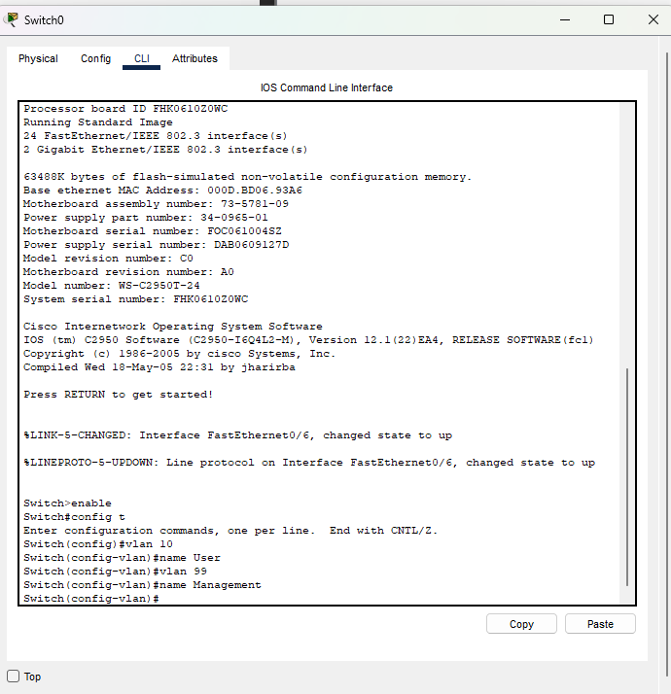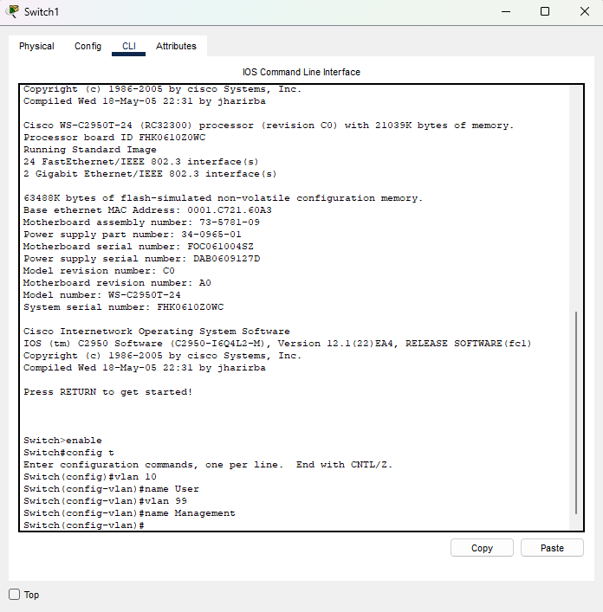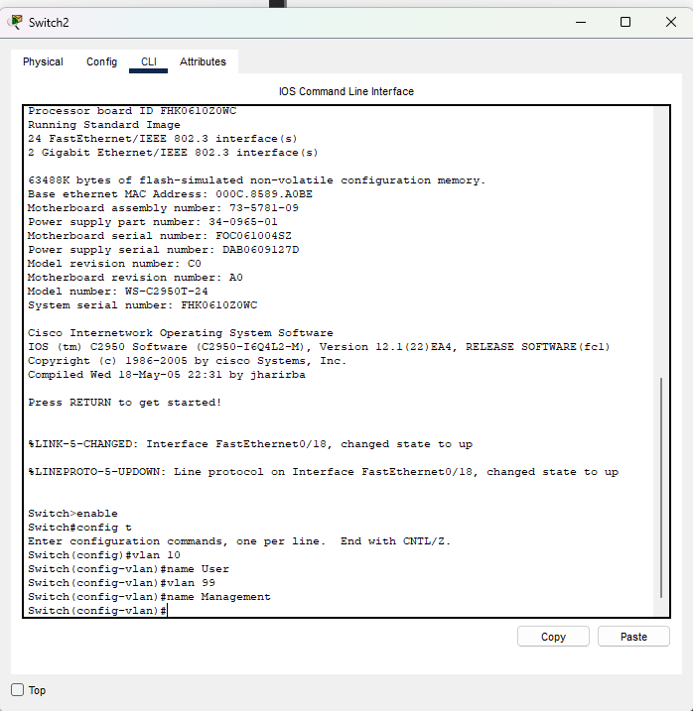
  - Enable user ports in access mode and assign VLANs.
For S1 F0/6 and S3 F0/18, enable the ports, configure them as access ports, and assign them to VLAN 10.
  - Configure trunk ports and assign to native VLAN 99.
For ports F0/1 and F0/3 on all switches, enable the ports, configure them as trunk ports, and assign them to native VLAN 99.
  - Configure the management interface on all switches.
Using the Addressing Table, configure the management interface on all switches with the appropriate IP address.
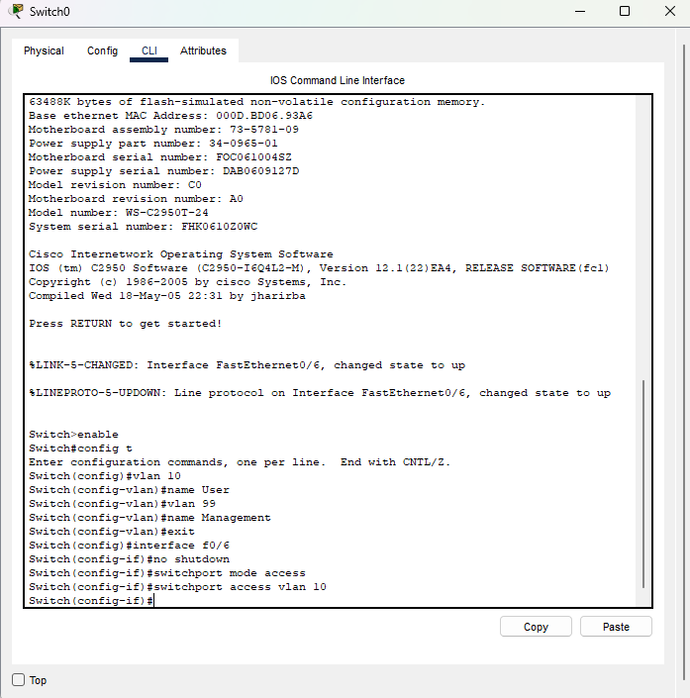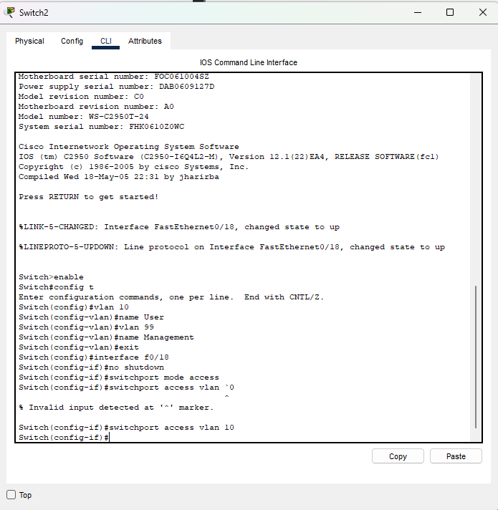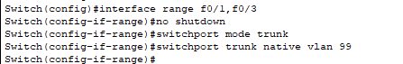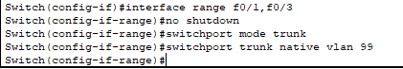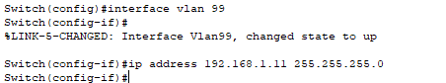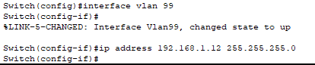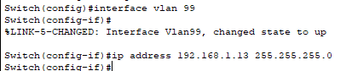
  - Verify configurations and connectivity.
Use the show vlan brief command on all switches to verify that all VLANs are registered in the VLAN table and that the correct ports are assigned. 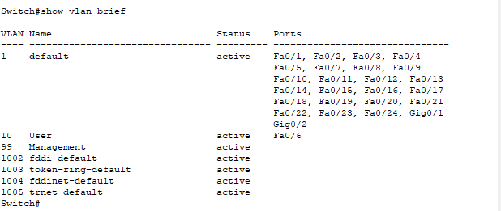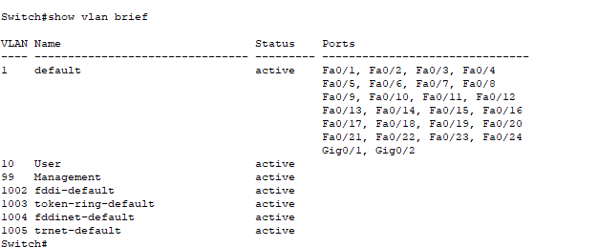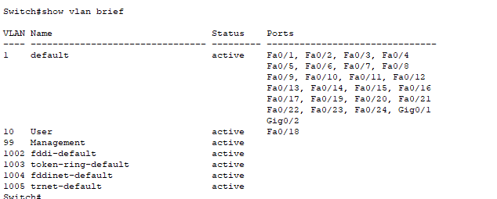
Use the show interfaces trunk command on all switches to verify trunk interfaces.
Use the show running-config command on all switches to verify all other configurations.
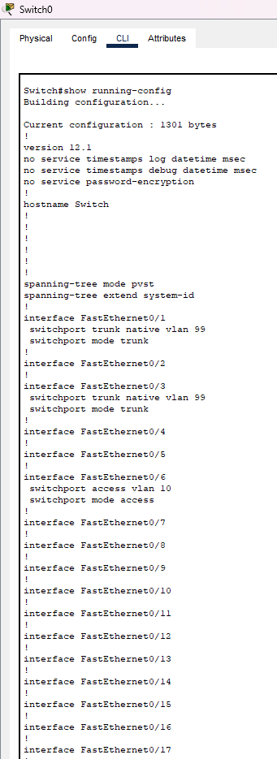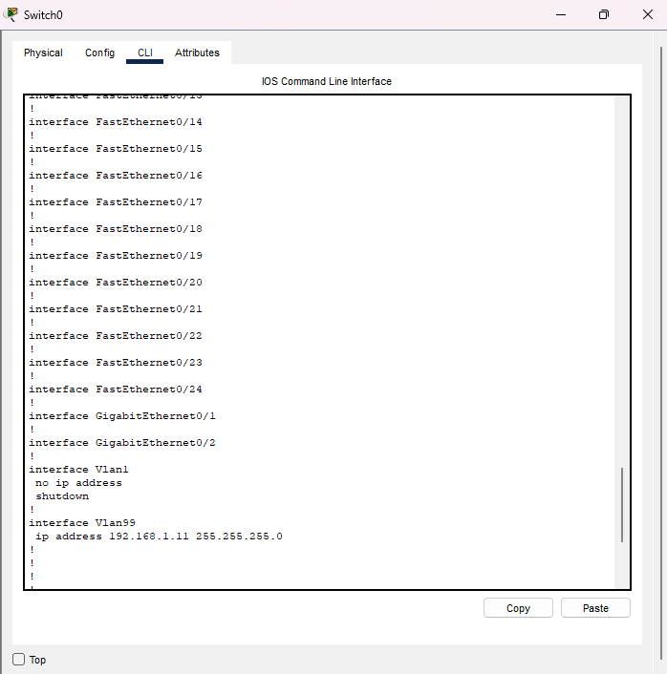
What is the default setting for spanning-tree mode on Cisco switches?
_The default spanning tree mode is PVST+
Verify connectivity between PC-A and PC-C. Was your ping successful? _____YES_________
If your ping was unsuccessful, troubleshoot the configurations until the issue is resolved.
Note: It may be necessary to disable the PC firewall to successfully ping between PCs.
- Configure the Root Bridge and Examine PVST+ Convergence
In Part 3, you will determine the default root in the network, assign the primary and secondary root, and use the debug command to examine convergence of PVST+.
Note: The required commands for Part 3 are provided in Appendix A. Test your knowledge by trying to configure the root bridge without referring to the appendix.
  - Determine the current root bridge.
Which command allows a user to determine the spanning-tree status of a Cisco Catalyst switch for all VLANs? Write the command in the space provided.
_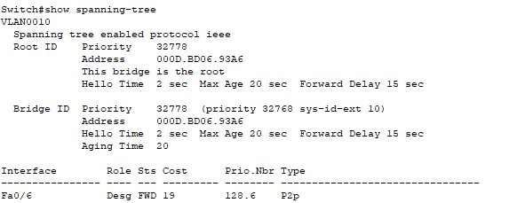_____________________________________________________________________________
Use the command on all three switches to determine the answers to the following questions:
Note: There are three instances of the spanning tree on each switch. The default STP configuration on Cisco switches is PVST+, which creates a separate spanning tree instance for each VLAN (VLAN 1 and any user-configured VLANs).
What is the bridge priority of switch S1 for VLAN 1? __32769____________

What is the bridge priority of switch S2 for VLAN 1? __32769____________
What is the bridge priority of switch S3 for VLAN 1? ___32769___________
Which switch is the root bridge? _switch S3_____________
Why was this switch elected as the root bridge? By default, spanning tree elects the root bridge based on lowest MAC address.
______________________________________________________________________________
  - Configure a primary and secondary root bridge for all existing VLANs.
Having a root bridge (switch) elected by MAC address may lead to a suboptimal configuration. In this lab, you will configure switch S2 as the root bridge and S1 as the secondary root bridge.
    - Configure switch S2 to be the primary root bridge for all existing VLANs. Write the command in the space provided.
_______S2(config)# spanning-tree vlan 1,10,99 root primary
___________________________________________________________________
    - Configure switch S1 to be the secondary root bridge for all existing VLANs. Write the command in the space provided.
______S1(config)# spanning-tree vlan 1,10,99 root secondary
_____________________________________________________________________
Use the show spanning-tree command to answer the following questions:
What is the bridge priority of S1 for VLAN 1? _______28673_______
What is the bridge priority of S2 for VLAN 1? ____24577__________
Which interface in the network is in a blocking state?_Interface F0/3 on switch S3______________________________
  - Change the Layer 2 topology and examine convergence.
To examine PVST+ convergence, you will create a Layer 2 topology change while using the debug command to monitor spanning-tree events.
    - Enter the debug spanning-tree events command in privileged EXEC mode on switch S3.
S3# debug spanning-tree events
Spanning Tree event debugging is on
    - Create a topology change by disabling interface F0/1 on S3.
S3(config)# interface f0/1
S3(config-if)# shutdown
*Mar 1 00:58:56.225: STP: VLAN0001 new root port Fa0/3, cost 38
*Mar 1 00:58:56.225: STP: VLAN0001 Fa0/3 -> listening
*Mar 1 00:58:56.225: STP[1]: Generating TC trap for port FastEthernet0/1
*Mar 1 00:58:56.225: STP: VLAN0010 new root port Fa0/3, cost 38
*Mar 1 00:58:56.225: STP: VLAN0010 Fa0/3 -> listening
*Mar 1 00:58:56.225: STP[10]: Generating TC trap for port FastEthernet0/1
*Mar 1 00:58:56.225: STP: VLAN0099 new root port Fa0/3, cost 38

*Mar 1 00:58:56.225: STP: VLAN0099 Fa0/3 -> listening
*Mar 1 00:58:56.225: STP[99]: Generating TC trap for port FastEthernet0/1
*Mar 1 00:58:56.242: %LINEPROTO-5-UPDOWN: Line protocol on Interface Vlan1, changed state to down
*Mar 1 00:58:56.242: %LINEPROTO-5-UPDOWN: Line protocol on Interface Vlan99, changed state to down
*Mar 1 00:58:58.214: %LINK-5-CHANGED: Interface FastEthernet0/1, changed state to administratively down
*Mar 1 00:58:58.230: STP: VLAN0001 sent Topology Change Notice on Fa0/3
*Mar 1 00:58:58.230: STP: VLAN0010 sent Topology Change Notice on Fa0/3
*Mar 1 00:58:58.230: STP: VLAN0099 sent Topology Change Notice on Fa0/3
*Mar 1 00:58:59.220: %LINEPROTO-5-UPDOWN: Line protocol on Interface FastEthernet0/1, changed state to down
*Mar 1 00:59:11.233: STP: VLAN0001 Fa0/3 -> learning
*Mar 1 00:59:11.233: STP: VLAN0010 Fa0/3 -> learning
*Mar 1 00:59:11.233: STP: VLAN0099 Fa0/3 -> learning
*Mar 1 00:59:26.240: STP[1]: Generating TC trap for port FastEthernet0/3
*Mar 1 00:59:26.240: STP: VLAN0001 Fa0/3 -> forwarding
*Mar 1 00:59:26.240: STP[10]: Generating TC trap for port FastEthernet0/3
*Mar 1 00:59:26.240: STP: VLAN0010 sent Topology Change Notice on Fa0/3
*Mar 1 00:59:26.240: STP: VLAN0010 Fa0/3 -> forwarding
*Mar 1 00:59:26.240: STP[99]: Generating TC trap for port FastEthernet0/3
*Mar 1 00:59:26.240: STP: VLAN0099 Fa0/3 -> forwarding
*Mar 1 00:59:26.248: %LINEPROTO-5-UPDOWN: Line protocol on Interface Vlan1, changed state to up
*Mar 1 00:59:26.248: %LINEPROTO-5-UPDOWN: Line protocol on Interface Vlan99, changed state to up
Note: Before proceeding, use the debug output to verify that all VLANs on F0/3 have reached a forwarding state then use the command no debug spanning-tree events to stop the debug output.
Through which port states do each VLAN on F0/3 proceed during network convergence?
Listening, learning, and forwarding
Using the time stamp from the first and last STP debug message, calculate the time (to the nearest second) that it took for the network to converge. Hint: The debug timestamp format is date hh.mm.ss:msec.
30 seconds
- Configure Rapid PVST+, PortFast, BPDU Guard, and Examine Convergence
In Part 4, you will configure Rapid PVST+ on all switches. You will configure PortFast and BPDU guard on all access ports, and then use the debug command to examine Rapid PVST+ convergence.
Note: The required commands for Part 4 are provided in Appendix A. Test your knowledge by trying to configure the Rapid PVST+, PortFast, and BPDU guard without referring to the appendix.
  - Configure Rapid PVST+.
    - Configure S1 for Rapid PVST+. Write the command in the space provided.
S1(config)# spanning-tree mode rapid-pvst
    - Configure S2 and S3 for Rapid PVST+.

S1(config)# interface f0/6

S1(config-if)# spanning-tree bpduguard enable

    - Verify configurations with the show running-config | include spanning-tree mode command.
S1# show running-config | include spanning-tree mode
spanning-tree mode rapid-pvst

S2# show running-config | include spanning-tree mode
spanning-tree mode rapid-pvst

S3# show running-config | include spanning-tree mode
spanning-tree mode rapid-pvst
  - Configure PortFast and BPDU Guard on access ports.
PortFast is a feature of spanning tree that transitions a port immediately to a forwarding state as soon as it is turned on. This is useful in connecting hosts so that they can start communicating on the VLAN instantly, rather than waiting on spanning tree. To prevent ports that are configured with PortFast from forwarding BPDUs, which could change the spanning tree topology, BPDU guard can be enabled. At the receipt of a BPDU, BPDU guard disables a port configured with PortFast.
    - Configure interface F0/6 on S1 with PortFast. Write the command in the space provided.

S1(config)# interface f0/6

S1(config-if)# spanning-tree bpduguard enable

    - Configure interface F0/6 on S1 with BPDU guard. Write the command in the space provided.

S1(config)# interface f0/6

S1(config-if)# spanning-tree bpduguard enable

    - Globally configure all non-trunking ports on switch S3 with PortFast. Write the command in the space provided.
- S3(config)# spanning-tree portfast default
    - Globally configure all non-trunking PortFast ports on switch S3 with BPDU guard. Write the command in the space provided.

S3(config)# spanning-tree portfast bpduguard default
  - Examine Rapid PVST+ convergence.
    - Enter the debug spanning-tree events command in privileged EXEC mode on switch S3.
    - Create a topology change by enabling interface F0/1 on switch S3.
S3(config)# interface f0/1
S3(config-if)# no shutdown
*Mar 1 01:28:34.946: %LINK-3-UPDOWN: Interface FastEthernet0/1, changed state to up
*Mar 1 01:28:37.588: RSTP(1): initializing port Fa0/1
*Mar 1 01:28:37.588: RSTP(1): Fa0/1 is now designated
*Mar 1 01:28:37.588: RSTP(10): initializing port Fa0/1
*Mar 1 01:28:37.588: RSTP(10): Fa0/1 is now designated
*Mar 1 01:28:37.588: RSTP(99): initializing port Fa0/1
*Mar 1 01:28:37.588: RSTP(99): Fa0/1 is now designated
*Mar 1 01:28:37.597: RSTP(1): transmitting a proposal on Fa0/1
*Mar 1 01:28:37.597: RSTP(10): transmitting a proposal on Fa0/1
*Mar 1 01:28:37.597: RSTP(99): transmitting a proposal on Fa0/1
*Mar 1 01:28:37.597: RSTP(1): updt roles, received superior bpdu on Fa0/1
*Mar 1 01:28:37.597: RSTP(1): Fa0/1 is now root port
*Mar 1 01:28:37.597: RSTP(1): Fa0/3 blocked by re-root
*Mar 1 01:28:37.597: RSTP(1): synced Fa0/1
*Mar 1 01:28:37.597: RSTP(1): Fa0/3 is now alternate
*Mar 1 01:28:37.597: RSTP(10): updt roles, received superior bpdu on Fa0/1
*Mar 1 01:28:37.597: RSTP(10): Fa0/1 is now root port
*Mar 1 01:28:37.597: RSTP(10): Fa0/3 blocked by re-root
*Mar 1 01:28:37.597: RSTP(10): synced Fa0/1
*Mar 1 01:28:37.597: RSTP(10): Fa0/3 is now alternate
*Mar 1 01:28:37.597: RSTP(99): updt roles, received superior bpdu on Fa0/1
*Mar 1 01:28:37.605: RSTP(99): Fa0/1 is now root port
*Mar 1 01:28:37.605: RSTP(99): Fa0/3 blocked by re-root
*Mar 1 01:28:37.605: RSTP(99): synced Fa0/1
*Mar 1 01:28:37.605: RSTP(99): Fa0/3 is now alternate
*Mar 1 01:28:37.605: STP[1]: Generating TC trap for port FastEthernet0/1
*Mar 1 01:28:37.605: STP[10]: Generating TC trap for port FastEthernet0/1
*Mar 1 01:28:37.605: STP[99]: Generating TC trap for port FastEthernet0/1
*Mar 1 01:28:37.622: RSTP(1): transmitting an agreement on Fa0/1 as a response to a proposal
*Mar 1 01:28:37.622: RSTP(10): transmitting an agreement on Fa0/1 as a response to a proposal
*Mar 1 01:28:37.622: RSTP(99): transmitting an agreement on Fa0/1 as a response to a proposal
*Mar 1 01:28:38.595: %LINEPROTO-5-UPDOWN: Line protocol on Interface FastEthernet0/1, changed state to up
Using the time stamp from the first and last RSTP debug message, calculate the time that it took for the network to converge
0.5 seconds
Reflection
  - What is the main benefit of using Rapid PVST+?
Rapid PVST+ decreases the time of Layer 2 convergence significantly over PVST+.
  - How does configuring a port with PortFast allow for faster convergence?
PortFast allows for an access port to immediately transition into a forwarding state which decreases Layer 2 convergence time.What protection does BPDU guard provide?
Appendix A – Switch Configuration Commands
Switch S1
S1(config)# vlan 10
S1(config-vlan)# name User
S1(config-vlan)# vlan 99
S1(config-vlan)# name Management
S1(config-vlan)# exit
S1(config)# interface f0/6
S1(config-if)# no shutdown
S1(config-if)# switchport mode access
S1(config-if)# switchport access vlan 10
S1(config-if)# interface f0/1
S1(config-if)# no shutdown

S1(config-if)# switchport mode trunk
S1(config-if)# switchport trunk native vlan 99
S1(config-if)# interface f0/3
S1(config-if)# no shutdown
S1(config-if)# switchport mode trunk
S1(config-if)# switchport trunk native vlan 99
S1(config-if)# interface vlan 99
S1(config-if)# ip address 192.168.1.11 255.255.255.0
S1(config-if)# exit
S1(config)# spanning-tree vlan 1,10,99 root secondary
S1(config)# spanning-tree mode rapid-pvst
S1(config)# interface f0/6
S1(config-if)# spanning-tree portfast
S1(config-if)# spanning-tree bpduguard enable
Switch S2
S2(config)# vlan 10
S2(config-vlan)# name User
S2(config-vlan)# vlan 99
S2(config-vlan)# name Management
S2(config-vlan)# exit
S2(config)# interface f0/1
S2(config-if)# no shutdown
S2(config-if)# switchport mode trunk
S2(config-if)# switchport trunk native vlan 99
S2(config-if)# interface f0/3
S2(config-if)# no shutdown
S2(config-if)# switchport mode trunk
S2(config-if)# switchport trunk native vlan 99
S2(config-if)# interface vlan 99
S2(config-if)# ip address 192.168.1.12 255.255.255.0
S2(config-if)# exit
S2(config)# spanning-tree vlan 1,10,99 root primary
S2(config)# spanning-tree mode rapid-pvst
Switch S3
S3(config)# vlan 10
S3(config-vlan)# name User
S3(config-vlan)# vlan 99
S3(config-vlan)# name Management

S3(config-vlan)# exit
S3(config)# interface f0/18
S3(config-if)# no shutdown
S3(config-if)# switchport mode access
S3(config-if)# switchport access vlan 10
S3(config-if)# spanning-tree portfast
S3(config-if)# spanning-tree bpduguard enable
S3(config-if)# interface f0/1
S3(config-if)# no shutdown
S3(config-if)# switchport mode trunk
S3(config-if)# switchport trunk native vlan 99
S3(config-if)# interface f0/3
S3(config-if)# no shutdown
S3(config-if)# switchport mode trunk
S3(config-if)# switchport trunk native vlan 99
S3(config-if)# interface vlan 99
S3(config-if)# ip address 192.168.1.13 255.255.255.0
S3(config-if)# exit
S3(config)# spanning-tree mode rapid-pvst

Signature of faculty in-charge

